**Name: Student ID:**

BRAC UNIVERSITY

LAB Final Examination

Course Title: Numerical Methods

Course ID-CSE 330

**Question 1[10 marks]:**



|  |  |  |  |  |  |  |  |  |  |
| --- | --- | --- | --- | --- | --- | --- | --- | --- | --- |
| X | 1 | 2 | 3 | 4 | 5 | 6 | 7 | 8 | 9 |
| Y | .5 | 1.7 | 3.4 | 5.7 | 8.4 | 9.2 | 10.6 | 11.3 | 12.7 |

Write the value of a2 and b2 on the question paper.

**Formula for linear regression:**

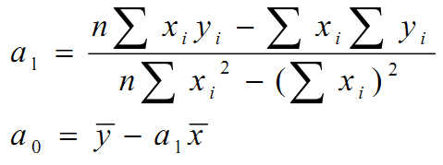

**Question 2[10 marks]:**

